EXPERIMENT NO. 02
SIMULATION AND ANALYSIS OF CMOS INVERTER
―――――――――――――――――――――――――――――――――――――――――――――――――――――――
AIM
To simulate and analyze the schematics, DC Voltage Transfer Characteristics (VTC), and transient response of a CMOS Inverter using LT Spice.
SOFTWARE USED
LT Spice
CIRCUIT DIAGRAM
The schematic diagrams for DC and transient analysis of the CMOS inverter:
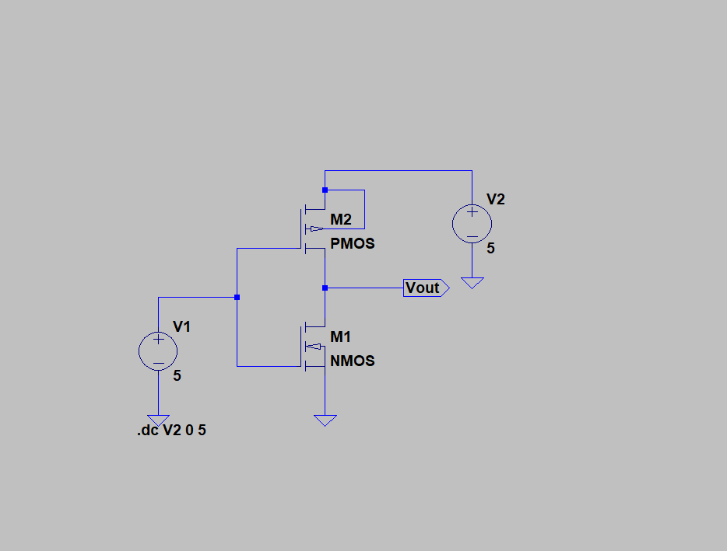
Figure 2.1: LT Spice Schematic for DC Transfer Characteristic Analysis
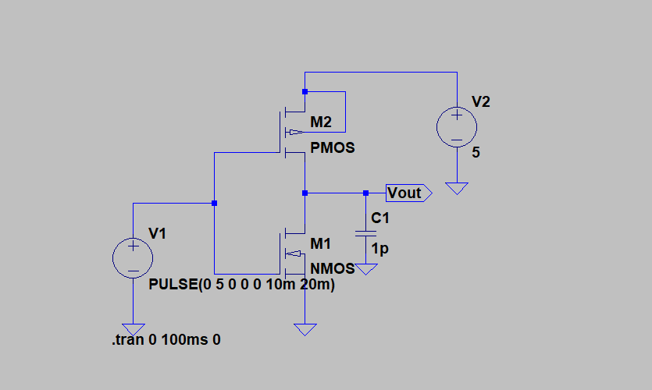
Figure 2.2: LT Spice Schematic for Transient Analysis
Basic structure of a complementary CMOS inverter:
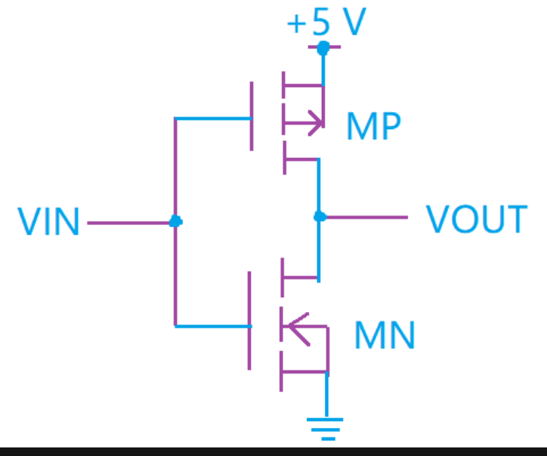
Figure 2.3: CMOS Inverter Transistor Structure
SMALL THEORY
The CMOS inverter is the fundamental logic building block of digital integrated circuits, performing the Boolean inversion operation (Y = A'). It consists of a p-channel MOSFET pull-up connected between VDD and output, and an n-channel MOSFET pull-down connected between output and ground (VSS), with a shared gate input.
- Low Input (Vin = 0V): When Vin = 0V (Logic 0), VGSn < VTn (NMOS is OFF) and |VGSp| > |VTP| (PMOS is ON). The PMOS pulls the output node up to VDD (Logic 1).
- High Input (Vin = VDD): When Vin = VDD (Logic 1), NMOS is ON and PMOS is OFF. The NMOS pulls the output node down to 0V (Logic 0).
- Key Characteristics: Virtually zero static power consumption because one transistor is always non-conducting in steady state; full rail-to-rail voltage swing (0V to VDD); high input impedance and large noise margins.
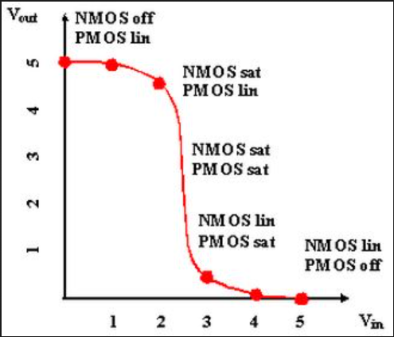
Figure 2.4: Theoretical Voltage Transfer Characteristics (VTC) of CMOS Inverter
OUTPUT GRAPH
Simulation results obtained from LT Spice:
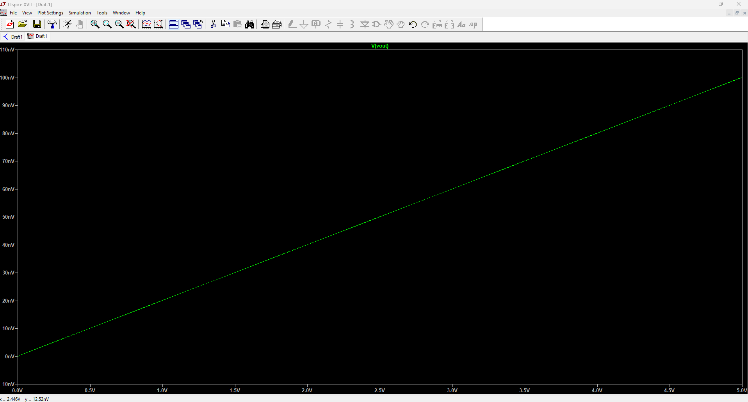
Figure 2.5: DC Voltage Transfer Characteristics (VTC: Vout vs Vin)
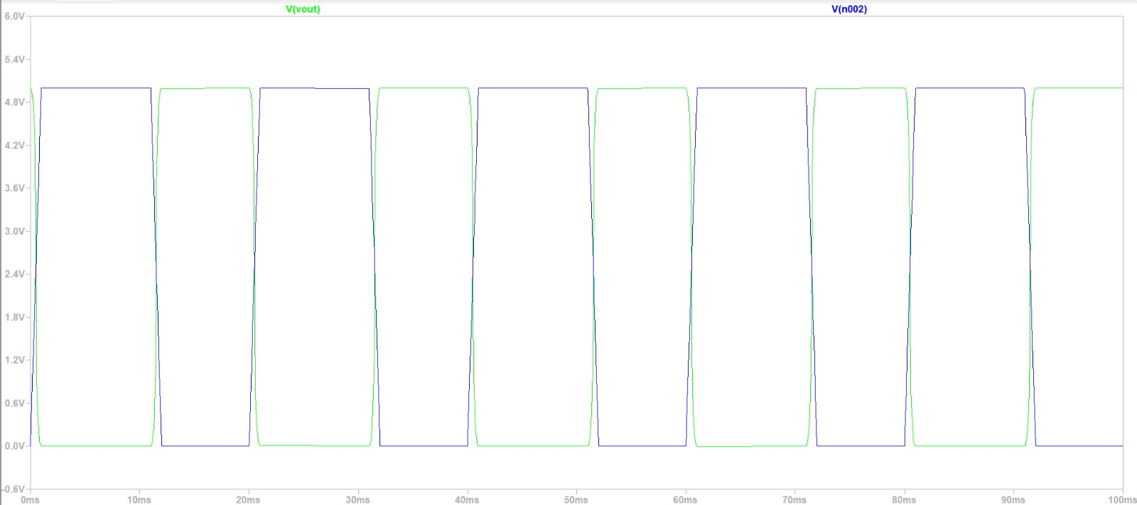
Figure 2.6: Transient Response Waveforms (Vin and Vout vs Time)

